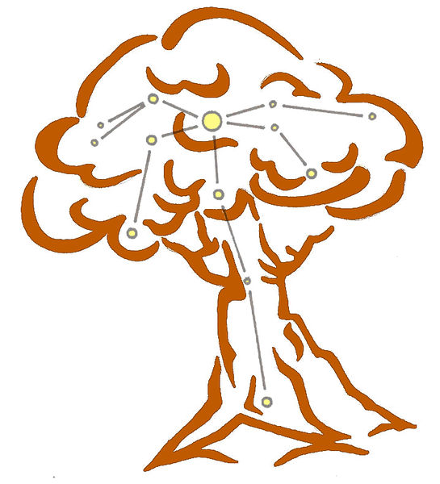

Unending Onslaught

Ritual of the Realm of Winter
Codified Spring 384YE by the magicians of Urizen under the guidance of Spyridonakes , the Doyen of the Spires


Developing the Ritual
This ritual was codified in 384YE by the spires of Urizen, under the guidance of Spyridonakes, the Doyen of the Spires. It was based on work originally performed by fellow Urizen Ematius.
Among those who helped to codify the ritual were several scholars in newly-Grendel occupied Spiral. While their aid helped to speed the formulation of the ritual it also means that Salt Lord Kalliact and her court are aware of the existance of this ritual – although it is unlikely to cause them any particular concern.
Unyielding Fortitude
This ritual grants the target the ability to overcome and endure significant injuries. As with enchantments such as Unyielding Constitution and especially Fight Tooth and Nail, it draws on the Winter resonance of survival – the drive to stay alive. With a few moments to recuperate, even the most savage blow to a limb can be overcome.
The enchantment does not heal so much as repair. By all accounts it can be quite a disconcerting effect to observe; a dislocated arm snapping back into position makes a certain sound that some find distinctly unsettling. Actually experiencing the effect can also be a little unsettling; those who have used it describe a flowering numbness that encompasses the ruined limb as bloodflow slows and fractured bone fuses together.
The enchantment also encourages the recipient to ensure that whatever has harmed them is never able to do so again. Being struck even by regular blows can fill them with a near uncontrollable rage and desire to obliterate the one who assaulted them.
The enchantment also has lingering effects. The first magicians to experience the enchantment spoke of peculiar incidents where the repaired limb blossomed with agonising pain, reminiscent of the original injury.
Performing the Ritual
The ritual is a personal enchantment, and is resonant with Verys (the rune of Strength) – a rune not often used with Winter magic. The first performance involved actually cutting the rune into the flesh of the recipient with a knife, and blood magic is particularly effective with this ritual. The blood of draughir appears to be unsurprisingly effective in this regard.
A goeticist might evoke the names of Sorin or Surut – both Winter eternals are associated with enduring or overcoming injury, and the rage that the enchantment can create in its recipient is particularly associatd with the Ashen Knight.
Astronomancy links this ritual to the constellation of The Oak (things endure), while a dramaturge might use the Doctor, the Blade, and the Battlefield.

Finally, this ritual certainly resonates with the totem of the Hydra – which represents regeneration and personal healing. One Navarri magician involved in the formulation insisted on calling it Hydra's Onslaught but the name never caught on with their fellow researchers.

Unending Onslaught

Winter Magnitude 12

Performing the Ritual
Performing this ritual takes at least 2 minutes of roleplaying. xxx.
The effect is an enchantment. A target may only be under one enchantment effect at a time.

Effects
The target gains the ability to use the relentless ability twice each day as if they know it without spending any hero points.
They also experience a roleplaying effect: Being struck fills you with rage and an urge to obliterate the one who struck you. Long after the enchantment has faded you will still occasionally feel agonizing pain in any limb you have restored through use of this enchantment.
The effect lasts until the start of the next Profound Decisions Empire event.

Additional Targets
The ritual can affect additional characters from the same banner. Each additional character increases the magnitude by 9. Additional characters must be present throughout.

OOC Note
This item is a ritual text.
Any character with the Winter Ritual Lore skill can master this ritual. You must have a free slot or experience point to master a new ritual. After an appropriate period of roleplaying spent studying these pages, it should then be brought to a referee who will add the ritual to those you have mastered. Doing this does not ‘use up’ the ritual text.
This ritual cannot be learned by other means; it cannot be taught by a character who knows it unless the ritual is added to the body of Imperial Lore by the Conclave.

Ribbon ID: 28017

