MAGICAL DEVICES

Detect Magic (Identify Magical Item) = Magical device, controls the flow of Autumn magic from the nearby regio. NO OTHER INFORMATION IS AVAILABLE, there is no need for them to cast any divination rituals, they shouldn’t waste their mana.

If removed from location and returned to Anvil, then they lose all magical power. At that point they are just a lump of metal. There is nothing to gain from them doing so.

Players have a riddle:
“Seal a Plot with the Great Wyrm; Place Wealth behind the Door; Seek Dominion upon the Mountain; Offer a Bargain to the Spider; Bind the Unnamed in the Chain”

The devices will cease to function if the following combinations are combined:

MAP NUMBER | LOCATION | DEVICE CONSTELLATION | MECHANISM RUNE
1 | Low Copse | 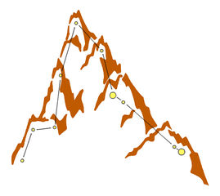 | 
2 | Mid Field | 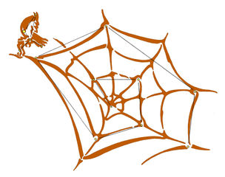 | 
3 | Top Field | 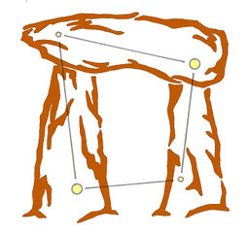 | 
4 | Fort | 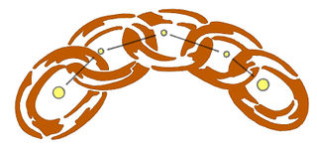 | The Unnamed Rune (A BLANK SPACE) THERE IS NO IMAGE HERE!
5 | Top Wood | 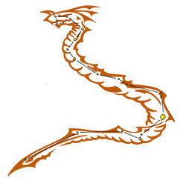 | 

