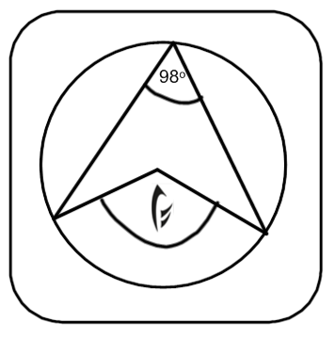 | Greetings Bard  For those who have been gifted this invite, may bring this token and attend an audience with Ylenrith at the Equinox.  If their mind is sharp and they take what they find into sixteen, then the pitch and duration may be found for a motif that may be used to seek passage.  A tune should be fashioned for Ylenrith, starting with the note of the mortal realm and ending in the note of the realm of the day.  The answers to the runes will give you a motif that you must work into your tune.  May the wisest and most creative be granted an audience.
